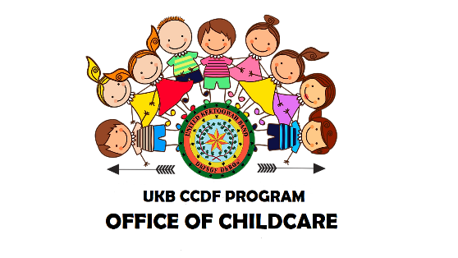
UKB CCDF Distance Learning
Program application

Parent or Guardian Name: __________________________________________
- Mailing Address: ____________________________________________________
____________________________________________________
- Physical Address: ___________________________________________________
- Phone: _________________ Email address: ____________________________
- UKB District: ______________________________________________________

Name of Child: _____________________________________________________
- Child’s Tribal Enrollment Number: _____________________________________
- Date of Birth: _______________ Grade: _______________
- Name of School: ____________________________________________________
- School Setting:
Public School Private School Home School Pre-K

- I certify under penalty of law that I am the custodial parent or legal guardian of the child named on this application
- I certify that all information submitted on this application is true and accurate
- I agree that the UKB CCDF Program is not responsible for the upkeep of the tablet being issued
- I understand that only one tablet will be issued to the child named on this application.
- I understand the tablet issued is to be used to assist the child in continuing their education during the COVID-19 pandemic

_______________________________________ _______________
Parent or Guardian Signature Date

