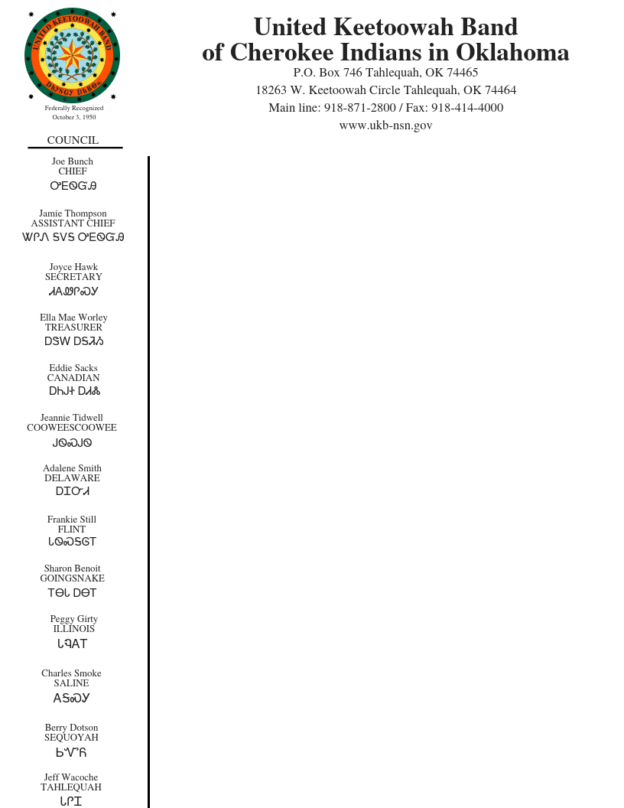

**August 2020 Public Notice**

**LIHEAP**

**(Low Income Energy Assistance Program)**

**Services begin October 1st to September 30th**

The LIHEAP Program is an Energy Assistance Program designed to assist low income households with home heating, cooling, and energy crisis intervention assistance.

**Residential HEATING Assistance (October 1- March 31)**.

This program aids eligible households with their primary source of heating: including wood, wood pellets, natural gas, propane, and electric (total electric households).

**Residential COOLING Assistance (April 30-September 30).**

This program aids eligible household with their primary source of cooling: electric. For UKB elders/disabled members additional assistance with window unit Air Conditioners and fans are available contingent on funding and timeframe of any previous receipt of a window unit.

**Crisis Assistance:**

Crisis Assistance is available to eligible UKB households under certain circumstance. Crisis Assistance includes utility assistance payment and other energy related expenses. Application process is required as well as a face to face meeting with Human Service Advocate. **Crisis Assistance is not guaranteed assistance**. Elder, disabled, and family with young children are priority applicants for Crisis Assistance.

**Applicants 55 years of age and older and disabled members are given priority service for the first three business days of each month.** All other eligible households will be assisted as funding permits.

Qualifications:

* + UBK Tribal member
  + Resident of the UKB nine district area
  + Meet income guideline (UKB HHS utilizes the 2020 State Median Income Guidelines
  + Completed application with all documents (including income) submitted via fax, email, in-person, or through UKB Council Representative.

Benefits will be paid directly to energy supplier/vendor. No payments will be paid directly to applicant.

To apply or for more information contact:

UKB Human Services

Jennifer Cole-Robinson UKB HHS Director

18263 W. Keetoowah Circle

Tahlequah, OK 74464

918-871-2853

Or contact your Tribal District Representative

*The Low Income Home Energy Assistance (LIHEAP) program is funded by the State’s Department of Health and Human Services and administered by the United Keetoowah Band Human Services Department. Date issued August 2020.