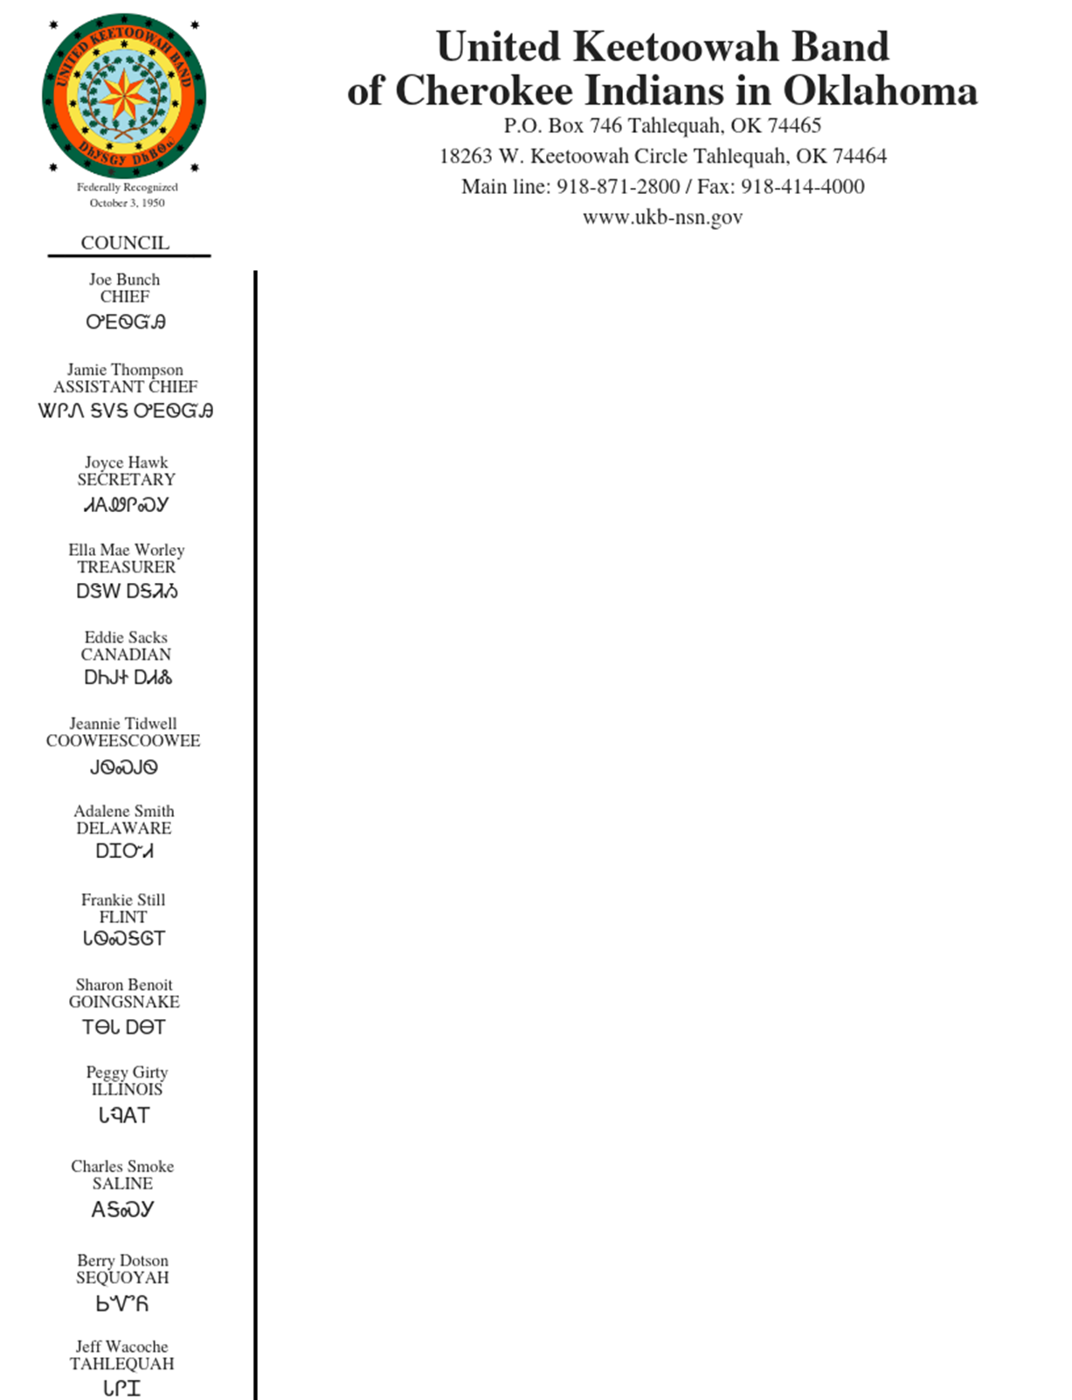

Public Announcement:

Applications can be obtained and submitted using the information listed above or by email: [sthompson@ukb-nsn.gov](mailto:sthompson@ukb-nsn.gov)

Closing Date: Until Filled

Opening Date: 11/06/2020

Position: Assistant Teacher

Department: Child Care

Reports to: Child Care Director

Pay: $9.00/HR

Status: Non-Exempt

**JOB SUMMARY**:

An Assistant Teacher will be responsible for assisting the teacher and master teacher in implementing lesson plans and other various tasks. He/She will assist in maintaining a positive learning environment conducive to the well-being of young children.

**ESSENTIAL DUTIES and RESPONSIBILITIES**:

* Implement with assistance individual and age appropriate group activities to stimulate growth in language, cognitive, social/emotional and motor skills.
  + Follow daily classroom schedule
* Assist master teacher and teacher in putting into practice classroom management plans through age appropriate lesson plans.
  + Follow weekly lesson plans.
* Demonstrate an understanding of developmentally appropriate practices. Ensure that all DHS licensing requirements are met and exhibit professional demeanor as outlined by NAEYC (National Association for the Education of Young Children).
* Demonstrate an ability to foresee, prevent and respond in hazardous situations.
* Assist teachers with classroom management.
* Keep parent board current with information.
* Help maintain a clean, child friendly learning environment.
* Ability to calculate and maintain child/staff ratios according to DHS standards.
* Actively supervise children at all times.
* Actively communicate with children.
* Oversee and assist in all handwashing.
* Assist in toileting and/or diaper changes.
* Participate in family style meals.
* Follow chain of command with issues and/or concerns.
* Attends all center meetings.
* All other duties as assigned.

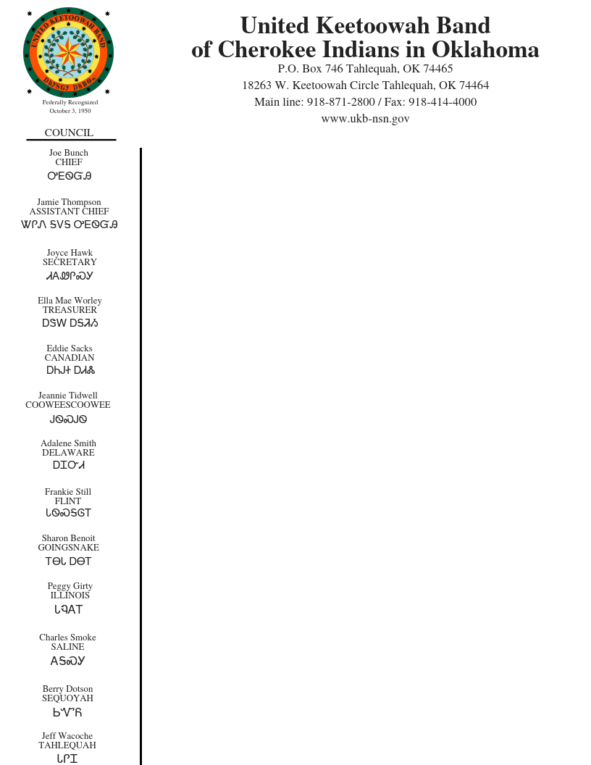

**QUALIFICATIONS**:

* Must be at least 18 years of age.
* Prefer 6 months to 1-year related experience in childcare.
* Applicant must receive CDA (Child Development Associate Credential) within first year of employment.
* Have first aid/CPR certificate, medication administration training (MAT), and ELCCT or receive after employment.
* Must pass OSBI fingerprint background check before employment.
* Actively maintain 20 hours of professional development per employment year.
* Must pass drug test.

**SUPERVISORY RESPONSIBILITIES**:

* Reports to site licensing quality coordinator.
* Understands and follows all policies and procedures, emergency, and safety protocols.

**PHYSICAL DEMANDS**:

While performing the duties of this job, the employee is regularly required to stand, walk, sit, stoop, kneel, crouch or crawl. The employee must frequently lift and/or move up to 25 pounds.