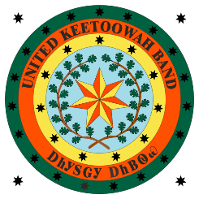
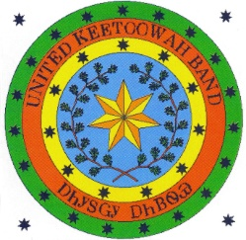
Federally Recognized
October 3, 1950

COUNCIL

Joe Bunch
CHIEF
ᎤᎬᏫᏳᎯ

Jeff Wacoche
ASSISTANT CHIEF
ᏔᎵᏁ ᎦᏙᎦ ᎤᎬᏫᏳᎯ

Joyce Hawk
SECRETARY
ᏗᎪᏪᎵᏍᎩ

Sonja Gourd
TREASURER
ᎠᏕᎳ ᎠᎦᏘᏱ

Eddie Sacks
CANADIAN
ᎠᏂᏧᏐ ᎠᏗᏠ

Cliff Wofford
COOWEESCOOWEE
ᎫᏫᏍᎫᏫ

Caleb Grimmett
DELAWARE
ᎠᏆᏅᏗ

Frankie Still
FLINT
ᏓᏫᏍᎦᎶᎢ

Willie Christie
GOINGSNAKE
ᎢᎾᏓ ᎠᎾᎢ

Peggy Girty
ILLINOIS
ᏓᏄᎪᎢ

Charles Smoke
SALINE
ᎪᎦᏍᎩ

Junior L. Catron
SEQUOYAH
ᏏᏉᏲ

Alvin Hicks
TAHLEQUAH
ᏓᎵᏆ

External Announcement:

Applications can be obtained and submitted using the information listed above or by email: sthompson@ukb-nsn.gov

Opening Date: 8/15/2022
Closing Date: Until Filled

Position: Office Assistant
Department: Enrollment
Reports to: Tribal Administrator
Pay: $11/HR
Status: Part-time as needed, Non-Exempt

JOB SUMMARY: The office assistant will be responsible for general clerical duties.

ESSENTIAL DUTIES AND RESPONSIBILITIES:

- Greeting members
- Filing, copying, sorting, faxing
- Answering the phone
- Other duties as assigned

EDUCATION AND/OR EXPERIENCE:

- Must be at least 18 years of age
- Must have a high school diploma or GED
- Must have a valid Driver License

SUPERVISORY RESPONSIBILITIES: None

UKB and Tribal Preference applies.

