INTERNAL/EXTERNAL ANNOUNCEMENT
Applications can be obtained and then submitted using the information listed above or by email: sthompson@ukb-nsn.gov
Opening Date: 11/09/2022
Closing Date: Until Filled
Position: Assistant Teacher
Department: Henry Lee Doublehead Child Development Center
Reports to: Site Manager/Director
Pay: $10/HR
Status: Full-Time, Non-Exempt
Job Summary: An Assistant Teacher will be responsible for assisting the teacher and master teacher in implementing lesson plans and other various tasks. He/She will assist in maintaining a positive learning environment conducive to the well-being of young children.

Essential Duties and Responsibilities
(Include and are not limited to the following assignment.)
- Implement with assistance individual and age-appropriate group activities to stimulate growth in language, cognitive, social/emotional and motor skills.
- Follows Daily Classroom Schedule
- Assist Master Teacher and Teacher in putting into practice classroom management plans through age-appropriate lesson plans.
- Follow Weekly lessons Plans.
- Demonstrate an understanding of Developmentally Appropriate Practices. Ensure that ALL DHS Licensing requirements are met and exhibit professional demeanor as outlined by NAEYC (National Association for the Education of Young Children).
- Demonstrate an ability to foresee, prevent, and respond in hazardous situations.
- Assist teachers with classroom management.
- Keep parent board current with information.
- Help Maintain a clean, child friendly learning environment.
- Ability to calculate and maintain child/staff ratios according to DHS standards.
- Actively supervise children at all times.
- Actively communicate with children.
- Oversee and assist in all handwashing.
- Assist in toileting and/or diaper changes.
- Participates in family style meals.
- Follow chain of command with issues and/or concerns.
- Attends all center meetings
- All other duties as assigned.
Other Qualifications: Must be able to pass a drug and alcohol screening and must have a clean driving record.
Education Required: High school diploma or GED.
UKB and Tribal preference applies.

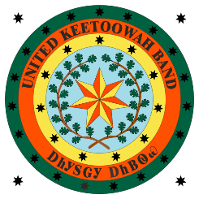
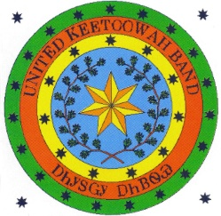
Federally Recognized
October 3, 1950

COUNCIL

Joe Bunch
CHIEF
ᎤᎬᏫᏳᎯ

Jeff Wacoche
ASSISTANT CHIEF
ᏔᎵᏁ ᎦᏙᎦ ᎤᎬᏫᏳᎯ

Joyce Hawk
SECRETARY
ᏗᎪᏪᎵᏍᎩ

Sonja Gourd
TREASURER
ᎠᏕᎳ ᎠᎦᏘᏱ

Eddie Sacks
CANADIAN
ᎠᏂᏧᏐ ᎠᏗᏠ

Cliff Wofford
COOWEESCOOWEE
ᎫᏫᏍᎫᏫ

Caleb Grimmett
DELAWARE
ᎠᏆᏅᏗ

Frankie Still
FLINT
ᏓᏫᏍᎦᎶᎢ

Willie Christie
GOINGSNAKE
ᎢᎾᏓ ᎠᎾᎢ

Peggy Girty
ILLINOIS
ᏓᏄᎪᎢ

Charles Smoke
SALINE
ᎪᎦᏍᎩ

Junior L. Catron
SEQUOYAH
ᏏᏉᏲ

Alvin Hicks
TAHLEQUAH
ᏓᎵᏆ

